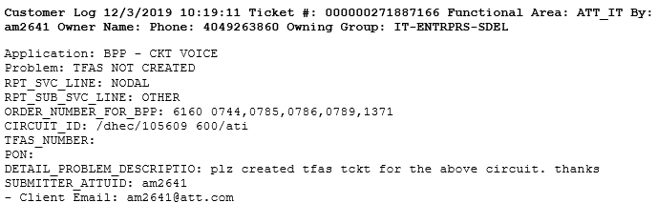

Generating TFAS is one of the major step is order flow in BPP

1. As we always do, Please go to SQL Query GUI with the link Mentioned and run the query mentioned in red. Here we will also see if the order is QRD or just Disconnect or a New Order. Because if it is QRD we won’t have to get TFAS number, TFAS Line will do the job.

(<http://bppcktv.it.att.com:8000/sql/index.html>)

SELECT * FROM SIFUSO WHERE ORDER_NO in ('61600744','61600785'')

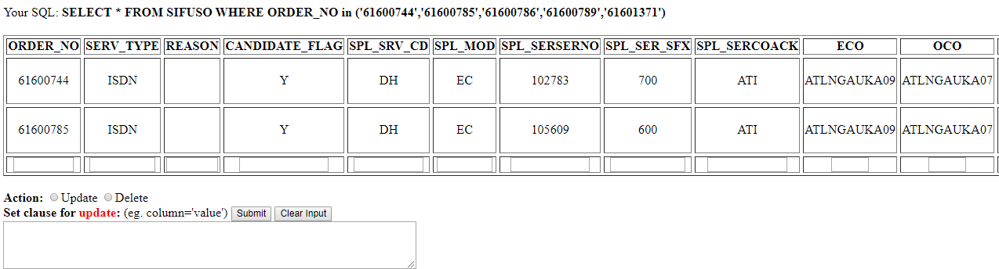

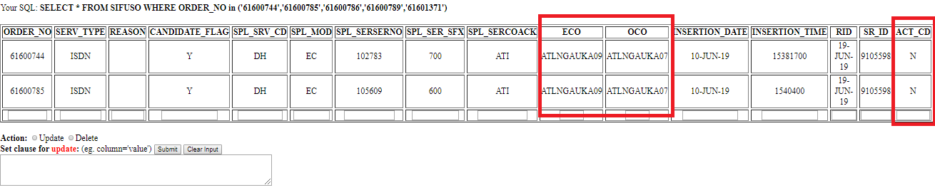

1. Go to get GUI Page and Paste the order as shown in the image below.

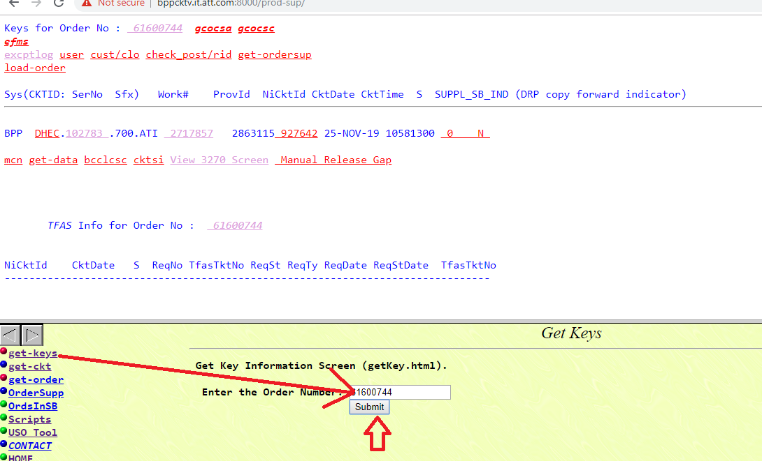

1. Once you click Submit you will find that that Order is partially loaded and TFAS Line and Number is missing. Missing Information is shown in the box below

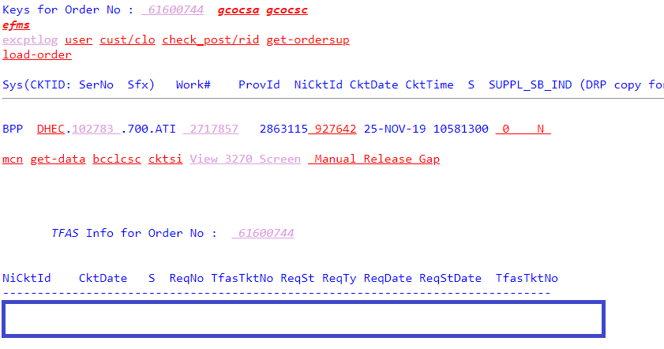

<http://bppcktv.it.att.com:8000/prod-sup/wrapper/ps-index.html>

1. We go to Production Script GUI and Start moving the order through Scheduling block and see how it responds

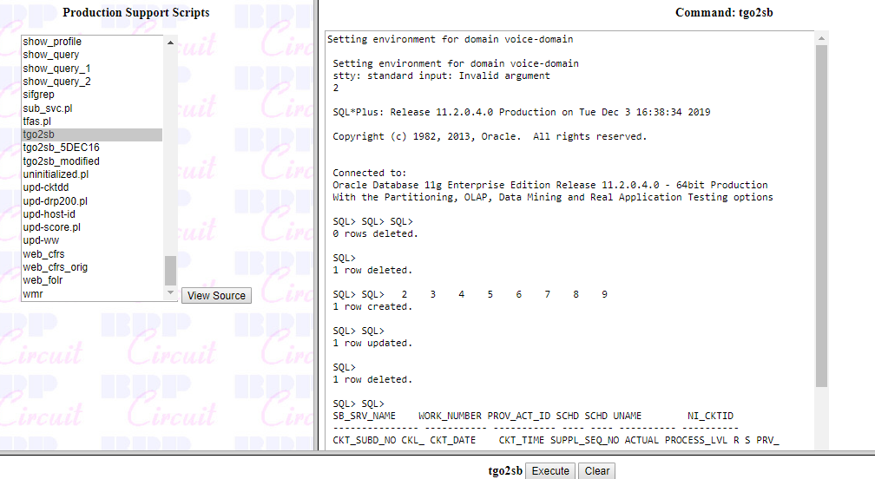

1. After pushing the order at 0705 Work Number- We can come back to the Get GUI page and see if it helped to create TFAS line or not. Or if that command had moved the order or not. If we click the WORK# as highlighted in screen shot below, we will be able to see scheduled block and previously scheduled block

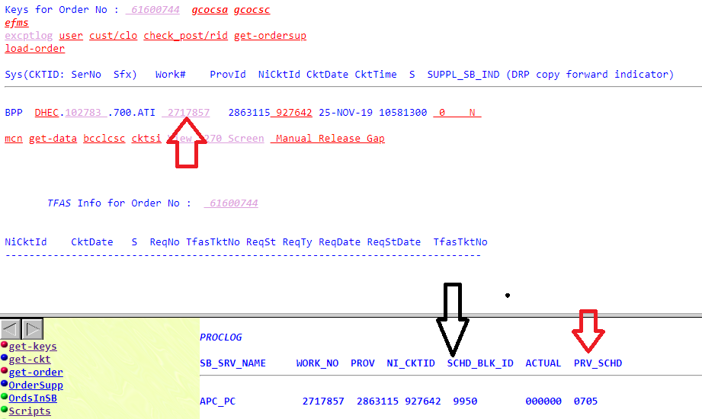

1. We go back to production script page and push the order to next scheduling block. As shown in screen shot **below 0300** and then 0310

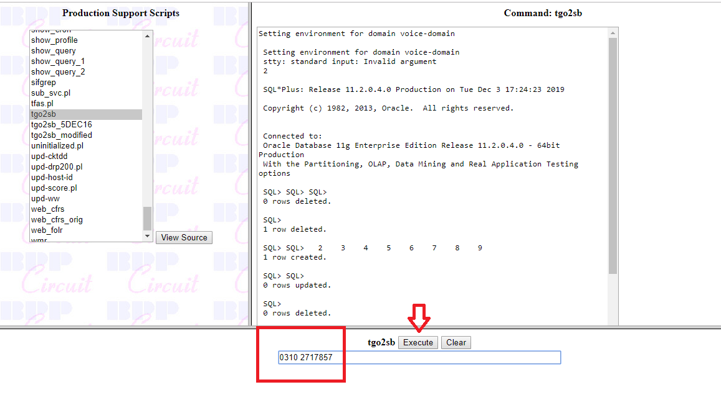

We will go to Order information GUI that TFAS Line has not be created.

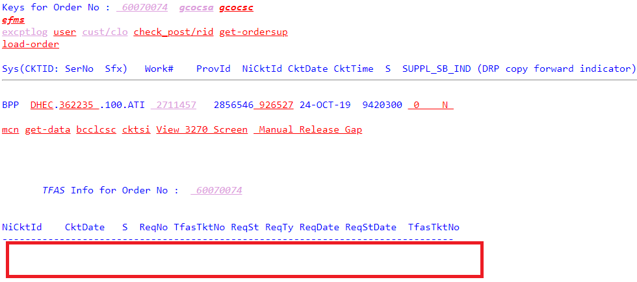

1. Next we will again go to Production Script Page and push to next scheduling block which is 0320

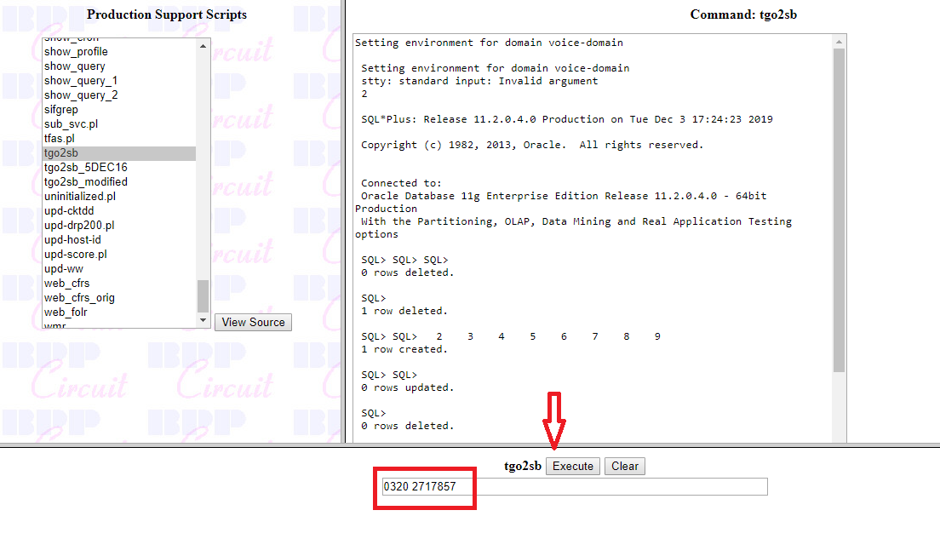

1. Go to Order information GUI and see if line is created. We can see line is created info is in red highlighted box but TFAS Ticket number is still missing. We will wait for few mins to see if it can automatically push it

Go 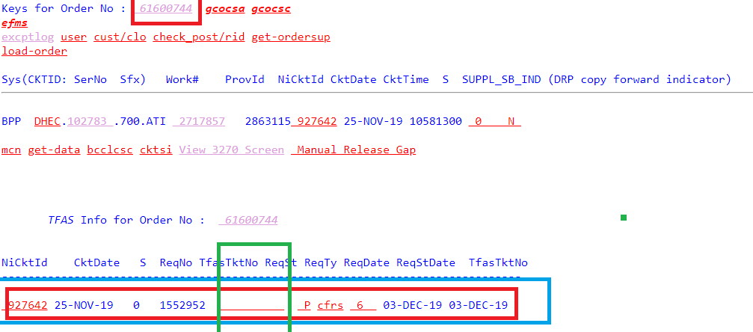

1. When automation does not push it to 0400 and create TFAS #. We will back to production script page and try to push for 0400

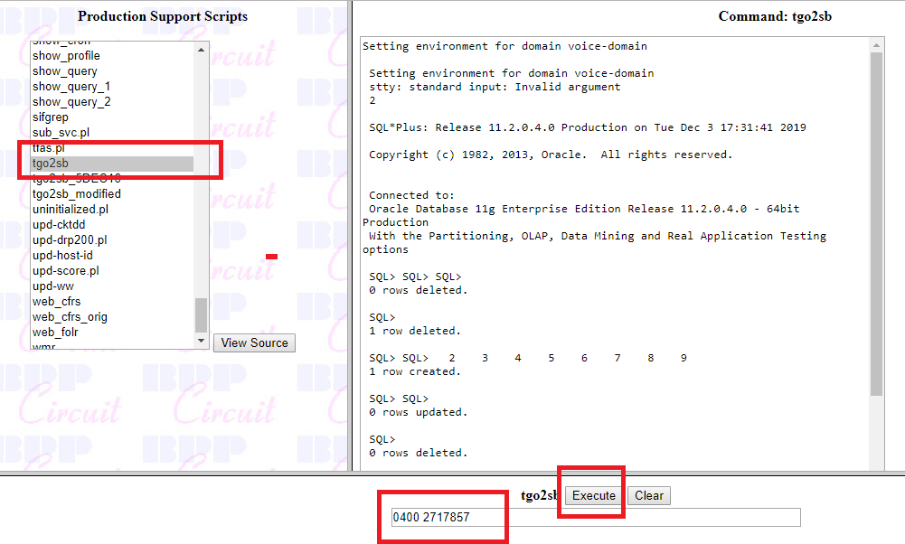

1. We go back to GUI page and see if TFAS number is created. If we don’t see and update on that we will click on WORK# and a dialogue box will open on the bottom . the information in the box below where it says SCHD_BBLK_ID -0500 means there is a issue.

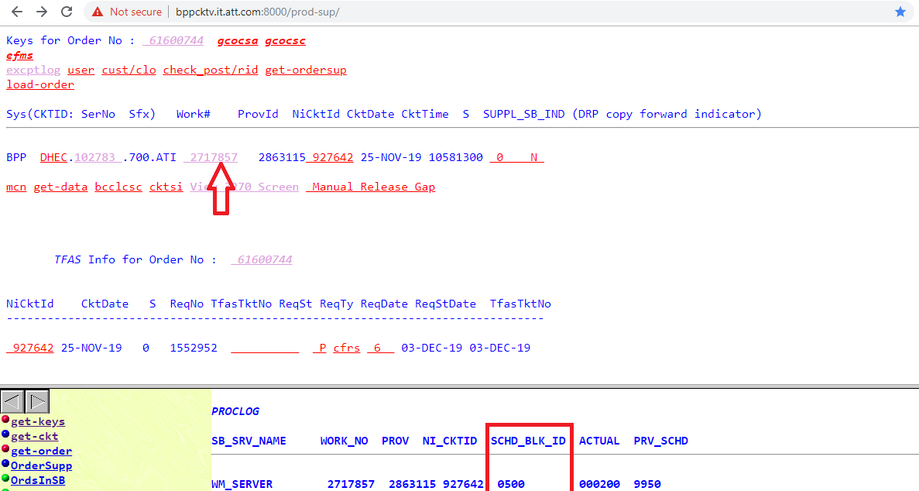

1. We will click on Except Log hyperlink on top left of the page and click it. Or other thing we can do is we can go to SQL Query and run a query in EXPECTLOG table with WORK Number and find the problem. Whenever we use the EXPECTLOG table- Please make sure please pick the latest time stamp line because a work number can have different issues earlier which got resolve so we don’t have to work on those issue. We have work on the present issue which is stopping us to GEN TFAS

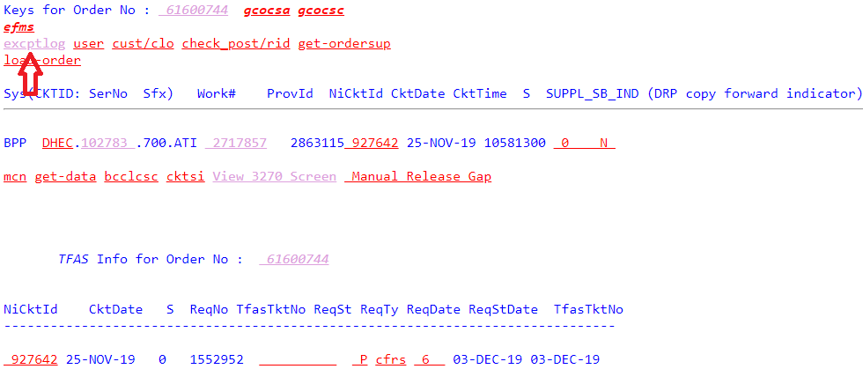

1. Once we see that we will find what is the error



1. No we go to HYPER Link @ GOSCA Screen and look for CLO Information. There can be scenarios that you wont find that information in CLO at that time you will ping the user with Ticket information and order number and would request the CLO Infor

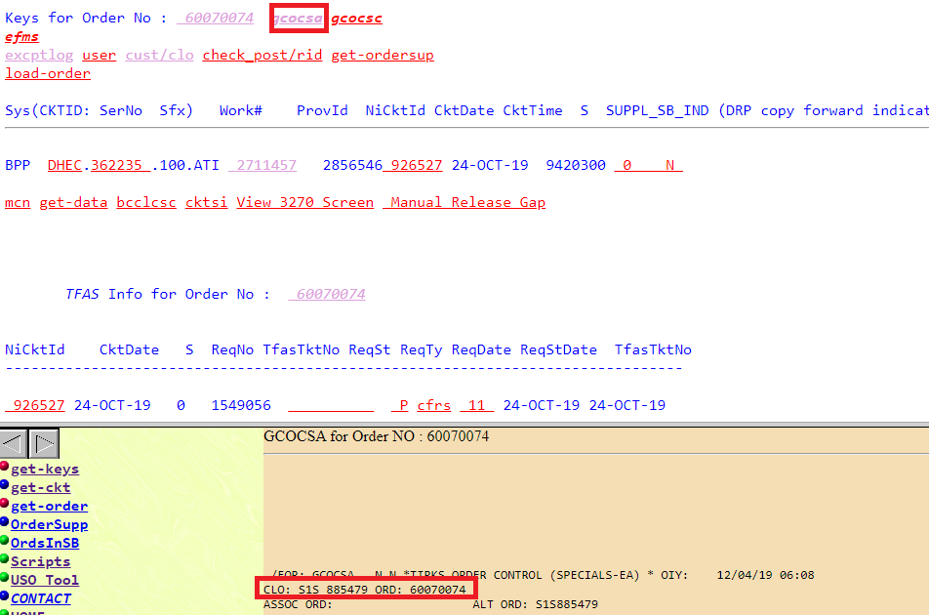

1. We will go to Production script page and go to get-clo command. Run the script

Order_no Clo TSF

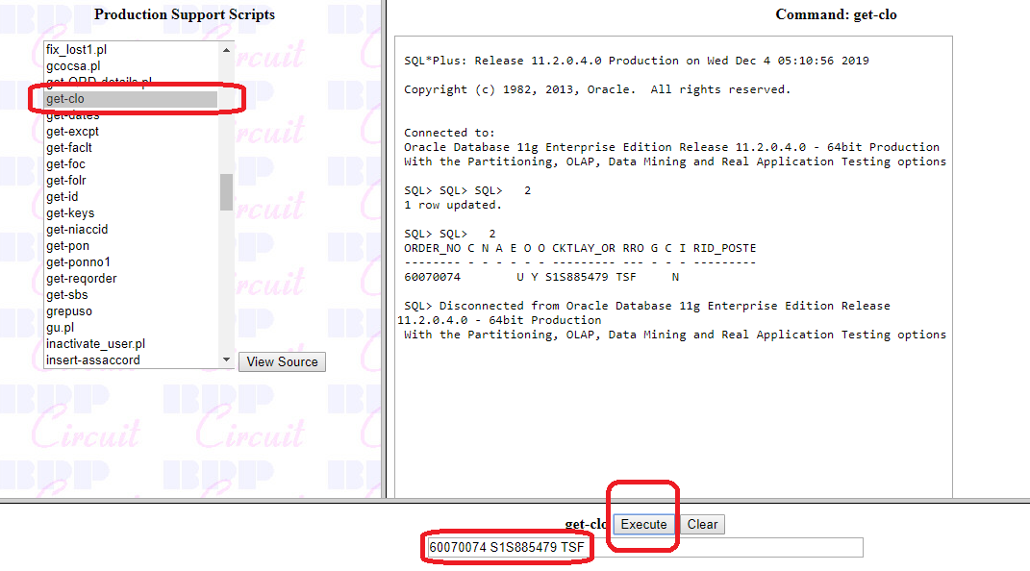

1. Once we do that we will need to use tgo2sb – production script to push the order to 0400 and try and get TFAS

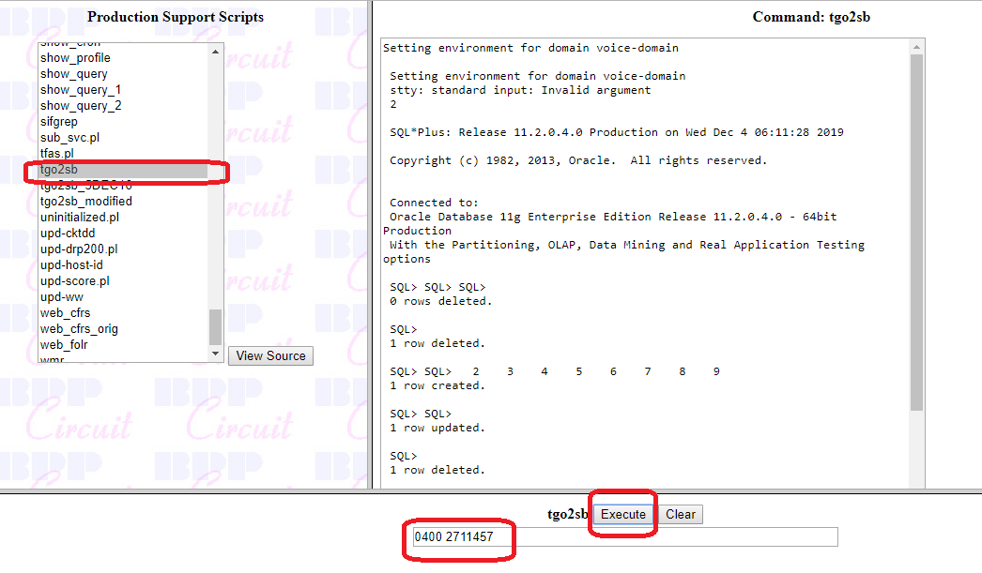

1. Once we push is we need to go back to Order info Page and see if TFAs is Generated. Once we have that means we have solved the issue.

